Arithmetic operators

Exercise #2

Flutter Developer Bootcamp

# **Purpose**

This exercise demonstrate and perform basic arithmetic operations using variables and constants.

**Problem**

This exercise illustrates basic arithmetic operations using variables a and b, initialized to 10 and 3 respectively. It computes and prints the sum, difference, product, quotient (as a double), and remainder of a and b. This example showcases fundamental Dart concepts like variable usage, arithmetic operators (+, -, *, /, %), and string interpolation for output formatting. It serves to illustrate how Dart handles numerical computations and displays results efficiently in a console environment.

**How to Solve**

1. Checkout the Exercise from Git Repo:

git clone -b <user-branch> <repo-URL>

2. Open the root folder inside VS Code

3. Open the root folder in terminal

4. Run the command dart run filename.dart

5. Create Variable declaration, arithmetic operators (+, -, *, /, %), data types (int, double), string interpolation, and output formatting using print() statements.

6. Execution: The program calculates and prints the sum, difference, product, quotient, and remainder of two integers (a and b), showcasing essential programming skills in Dart for handling numerical computations.

7. Go To File: <specific-file-with---method> à <method-name>, implement your logic.

**You will Achieve**

When you complete this exercise you will learn the following:

### **Functions and Methods Included:**

* main() Function:
  + Purpose: Entry point of the Dart program where execution begins.
  + Involvement: Orchestrates the execution of the arithmetic operations and outputting results using other functions and operators.
* Arithmetic Operators (+, -, *, /, %):
  + Purpose: Perform specific mathematical calculations.
  + Involvement: Used directly to compute values for sum, difference, product, quotient, and remainder based on the initialized variables a and b.
* print() Function:
  + Purpose: Output information to the console.
  + Involvement: Used to display the results (Sum: $sum, Difference: $difference, Product: $product, Quotient: $quotient, Remainder: $remainder) of the arithmetic operations.
* String Interpolation:
  + Purpose: Embed expressions within strings to construct dynamic output messages.
  + Involvement: Used to format and display computed values ($sum, $difference, $product, $quotient, $remainder) within the printed output strings.

# **Screenshots**

## **Expected output (Arithmetic operators)**

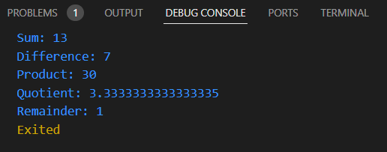

# **How to submit your exercise**

Push your project back to the same git branch using command:

<command name>

# **Happy Coding!**